- The drop in UK CPI inflation in September was in line with our forecast but below consensus expectations. The fall was largely due to base effects and a larger drag from the fuel category and will prove temporary. As a result, our inflation forecast is little changed, and we continue to expect CPI inflation to average 2.5% in 2024 and 2025.
- Inflation is likely to rebound strongly in October as Ofgem's higher energy price cap takes effect and September's base effects dissipate. Inflation will rise further around the turn of the year as base effects in the energy category come into play and services inflation remains sticky.
CPI inflation slowed to 1.7% in September from 2.2% in August, a move which was consistent with our forecast but below consensus expectations. September's decline had two key drivers. First, services inflation fell to 4.9% from 5.6% in August, owing in large part to base effects following a particularly strong outturn in September 2023. Second, a drop in oil prices meant petrol prices fell 3.9% m/m between August and September, versus a rise of similar magnitude between those months last year. Elsewhere, RPI and RPIX both declined by 0.8ppts to 2.7% and 2% respectively.
With today's data coming in broadly as expected, our inflation forecast is little changed compared with last month. September's fall in inflation should prove temporary given that the 10% rise in Ofgem's energy price cap came into force at the start of October and the base effects which weighed on September's reading should dissipate. CPI inflation is likely to drift higher around the turn of the year, owing to the fading drag from the energy category. This should more than offset a slight easing in core inflation.
We have incorporated a slightly weaker outlook for fuel prices into our forecast. While oil prices remain volatile, our Commodities Team has revised their 2025 oil price projection downwards by 6% on the basis that the price impact of the ongoing conflict in the Middle East should prove transitory, while there are signs of a supply glut and weaker demand from the US and China. However, this shift wasn't enough to materially alter our annual CPI inflation forecast, which remains at 2.5% this year and next.
Chart 1: CPI inflation is forecast to average 2.5% in 2024 and 2025
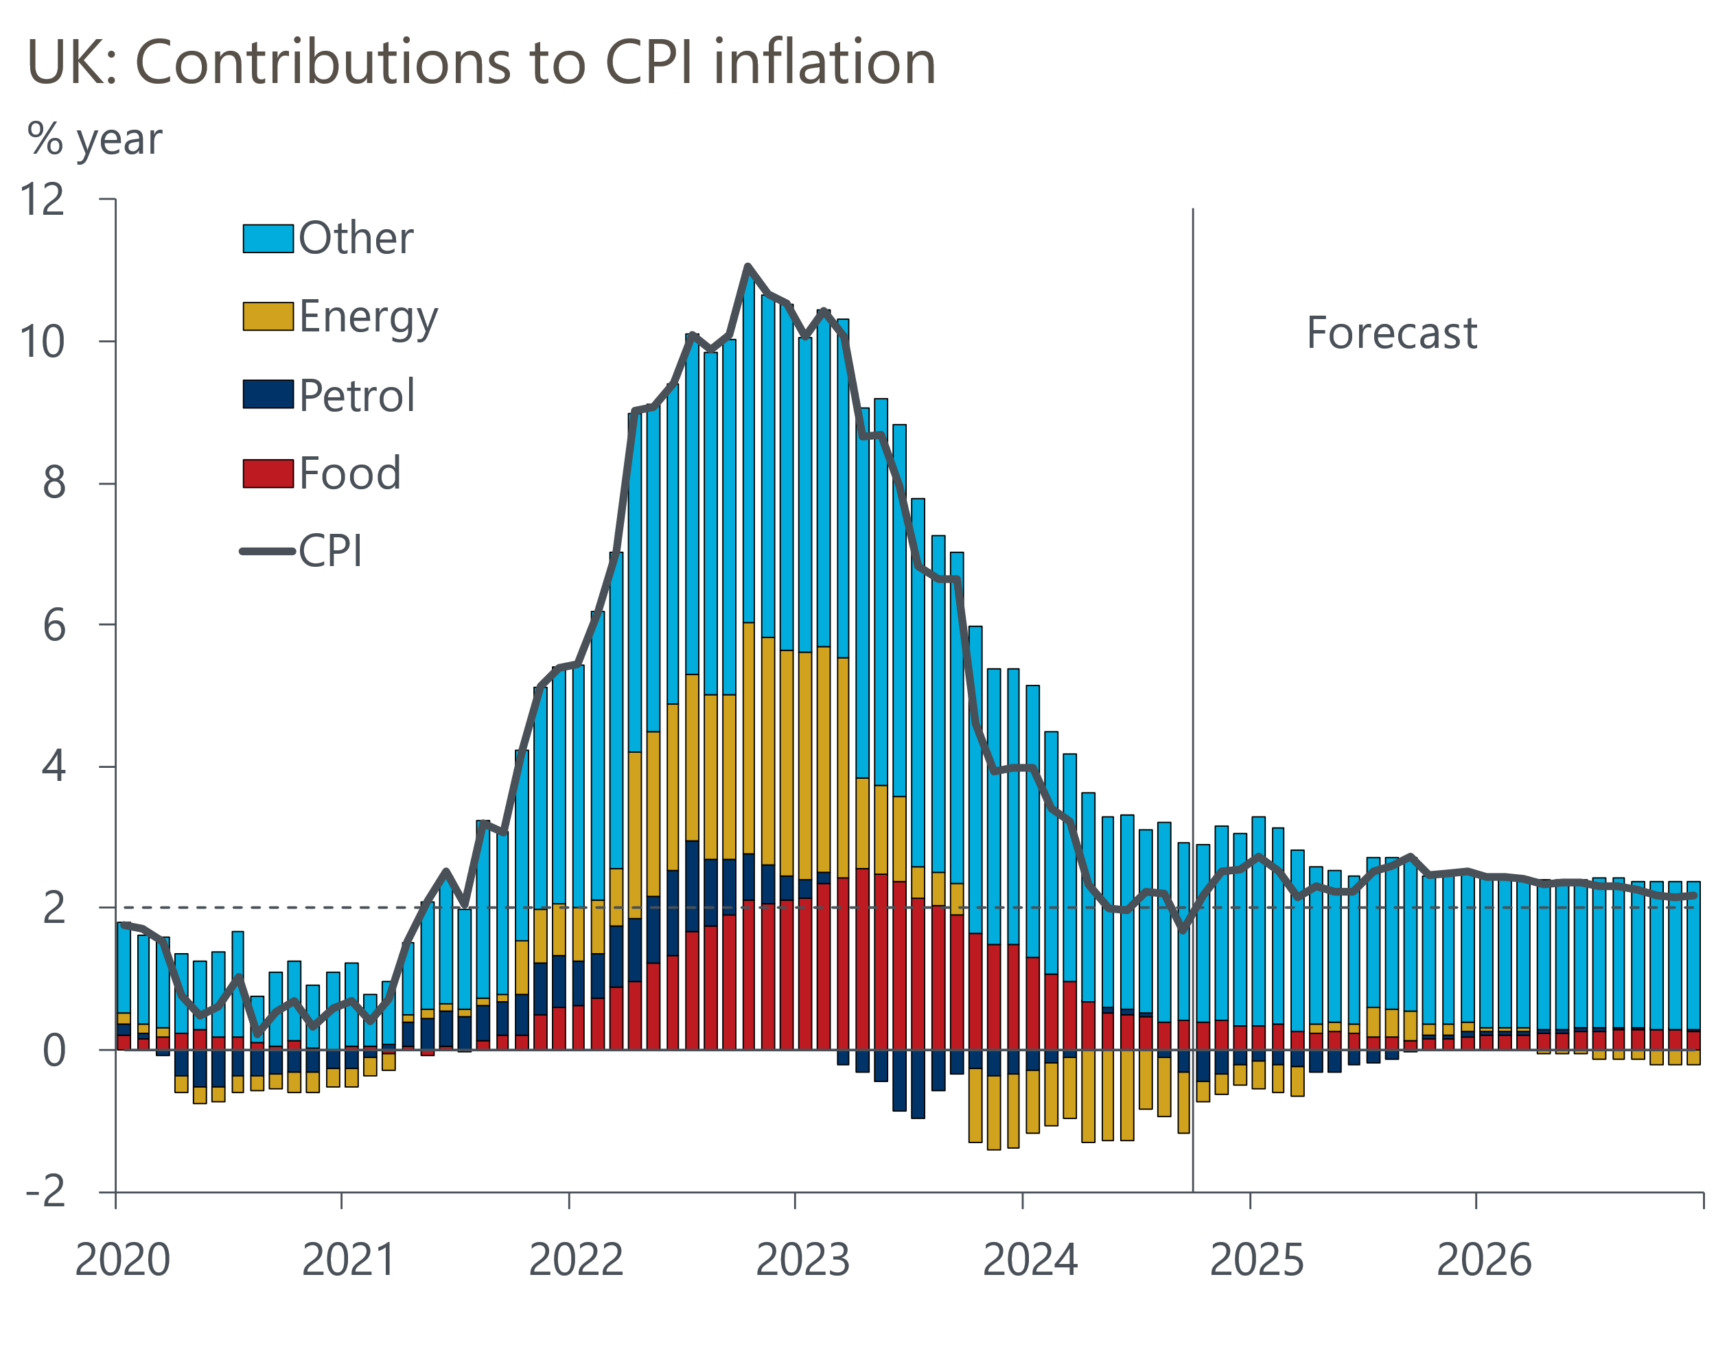
Source: Oxford Economics, Haver Analytics

